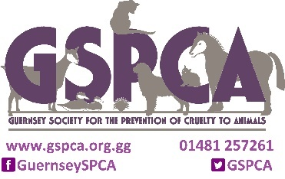
GSPCA Boarding information
Pets Name - __________________ Owners Name - ______________________________
Date of stay – From _______________________ To - _______________________
To help us with your pet(s) stay if would be wonderful to provide us ahead of your arrival with the following ideally by email admin@gspca.org.gg or please provide in writing on the arrival. Here is a list to help with the information that can help ensure your pet has a wonderful stay at the GSPCA -
Approximate time of arrival -
Approximate time of collection –
Destination (if off island) -
Up to date name and contact number for your emergency contact(s) we ideally need two minimum -
 | Name | Telephone Number | Telephone Number
1st Contact
2nd Contact
3rd Contact
Veterinary Practice
Dietary requirements and Instructions –

Vaccination Details (need to be up to date, type and date) -
Last Wormed -
Last Defleaed -
Any medication details (Type, quantity, times of day, etc) -

Any ailments or concerns to monitor -

Details of any bedding, toys -

Walking/socialising instructions (e.g. training harness to be used, doesn't like other animals, very friendly, prefers men/women, etc.) -

(continued over leaf)
Grooming instructions -

Any important behavioural information (e.g. nervous, chases ducks, jumps up, in season, etc.) -

Any details that might have changed (e.g. mobile number, email, etc) -

If you are happy for us to send you pictures of your pet(s) stay – yes / no
If you are happy for your pet(s) to feature on our social media/web site - yes / no
Any other useful information –

Signature of Owner -
Date Completed –

Please email and return to admin@gspca.org.gg
Or Post to –
GSPCA
Rue des Truchots
St Andrews
Guernsey
GY6 8UD
Telephone – 01481 257261

