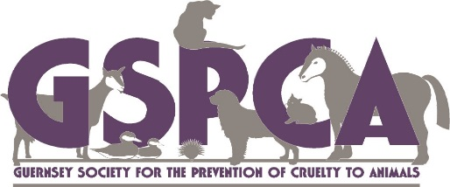
Paws for a Pint
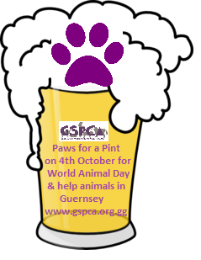
On World Animal Day
Get you pub, restaurant or hotel involved to help animals in Guernsey
Saturday 4th October
To register & get your pack please call 01481 257261 or email stevejbyrne@gspca.org.gg More details - www.gspca.org.gg

