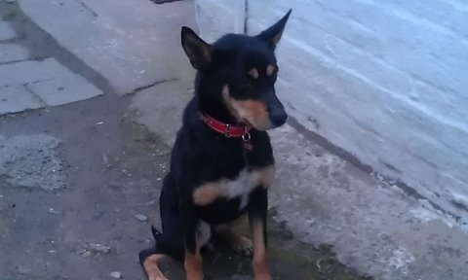
SIDNEY’S SPONSORED WALK ON SUNDAY 29TH APRIL 2012 AT 2PM
NAME OF WALKER:

NAME OF DOG:

ADDRESS:
TEL:

SPONSERS DETAILS & PLEDGE
NAME TELEPHONE £ DONATION SIGNATURE
1.

2.

3.

4.

5.

6.

7.

8.

9.

10.

11.

12.

13.

14.

15.

PROCEEDS TO GSPCA & WOODLANDS FARM KENNELS, BRIDPORT (RSPCA)
SIDNEY’S SPONSORED WALK ON SUNDAY 29TH APRIL 2012 AT 2PM
NAME OF WALKER:

NAME OF DOG:

ADDRESS:
TEL:

SPONSERS DETAILS & PLEDGE
NAME TELEPHONE £ DONATION SIGNATURE
16.

17.

18.

19.

20.

21.

22.

23.

24.

25.

26.

27.

28.

29.

30.

PROCEEDS TO GSPCA & WOODLANDS FARM KENNELS, BRIDPORT (RSPCA)

