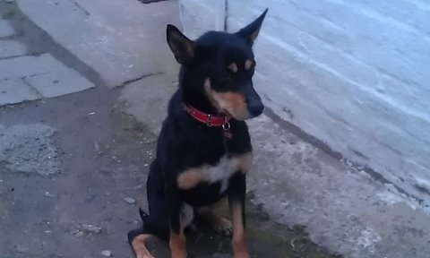
YOU ARE INVITED TO TAKE PART IN SIDNEY’S SPONSORED DOG WALK ON SUNDAY 29TH APRIL 2012.
MEETING FROM 1.00PM FOR REGISTRATION AND TO HAND IN COMPLETED FORMS & FUNDS
STARTING AT 2PM FROM GRANDES ROCQUES CAR PARK FINISHING AT L’ANCRESSE CAR PARK BY THE BEACHOUSE.
ALL DOGS MUST REMAIN ON A LEAD FOR DURATION OF THE WALK
THERE WILL BE WATER STOPS FOR DOGS AND OWNERS ALONG THE COURSE
DOGGY MESS BAGS AND BINS WILL ALSO BE PROVIDED
THE EVENT WILL BE FULLY MARSHALLED ESPECIALLY WHERE ROAD ACCESS IS REQUIRED
TO REQUEST A SPONSOR FORM PLEASE E-MAIL corinneconnolly@cwgsy.net
OR CALL 07911-720469
OR 266469 ANSWERPHONE
ALL PROCEEDS TO GSPCA & WOODLANDS FARM KENNELS (RSPCA - SIDNEY’S PREVIOUS HOME IN BRIDPORT)
ALL PARTICIPANTS WILL RECEIVE A CERTIFICATE FOR TAKING PART
In any event, it should be made clear to participants that they are responsible for their own safety on the walk and should check their personal liability cover in their household insurance. It must be stated that neither the Animal Charities nor the local organiser will be responsible for any loss or claim.’

