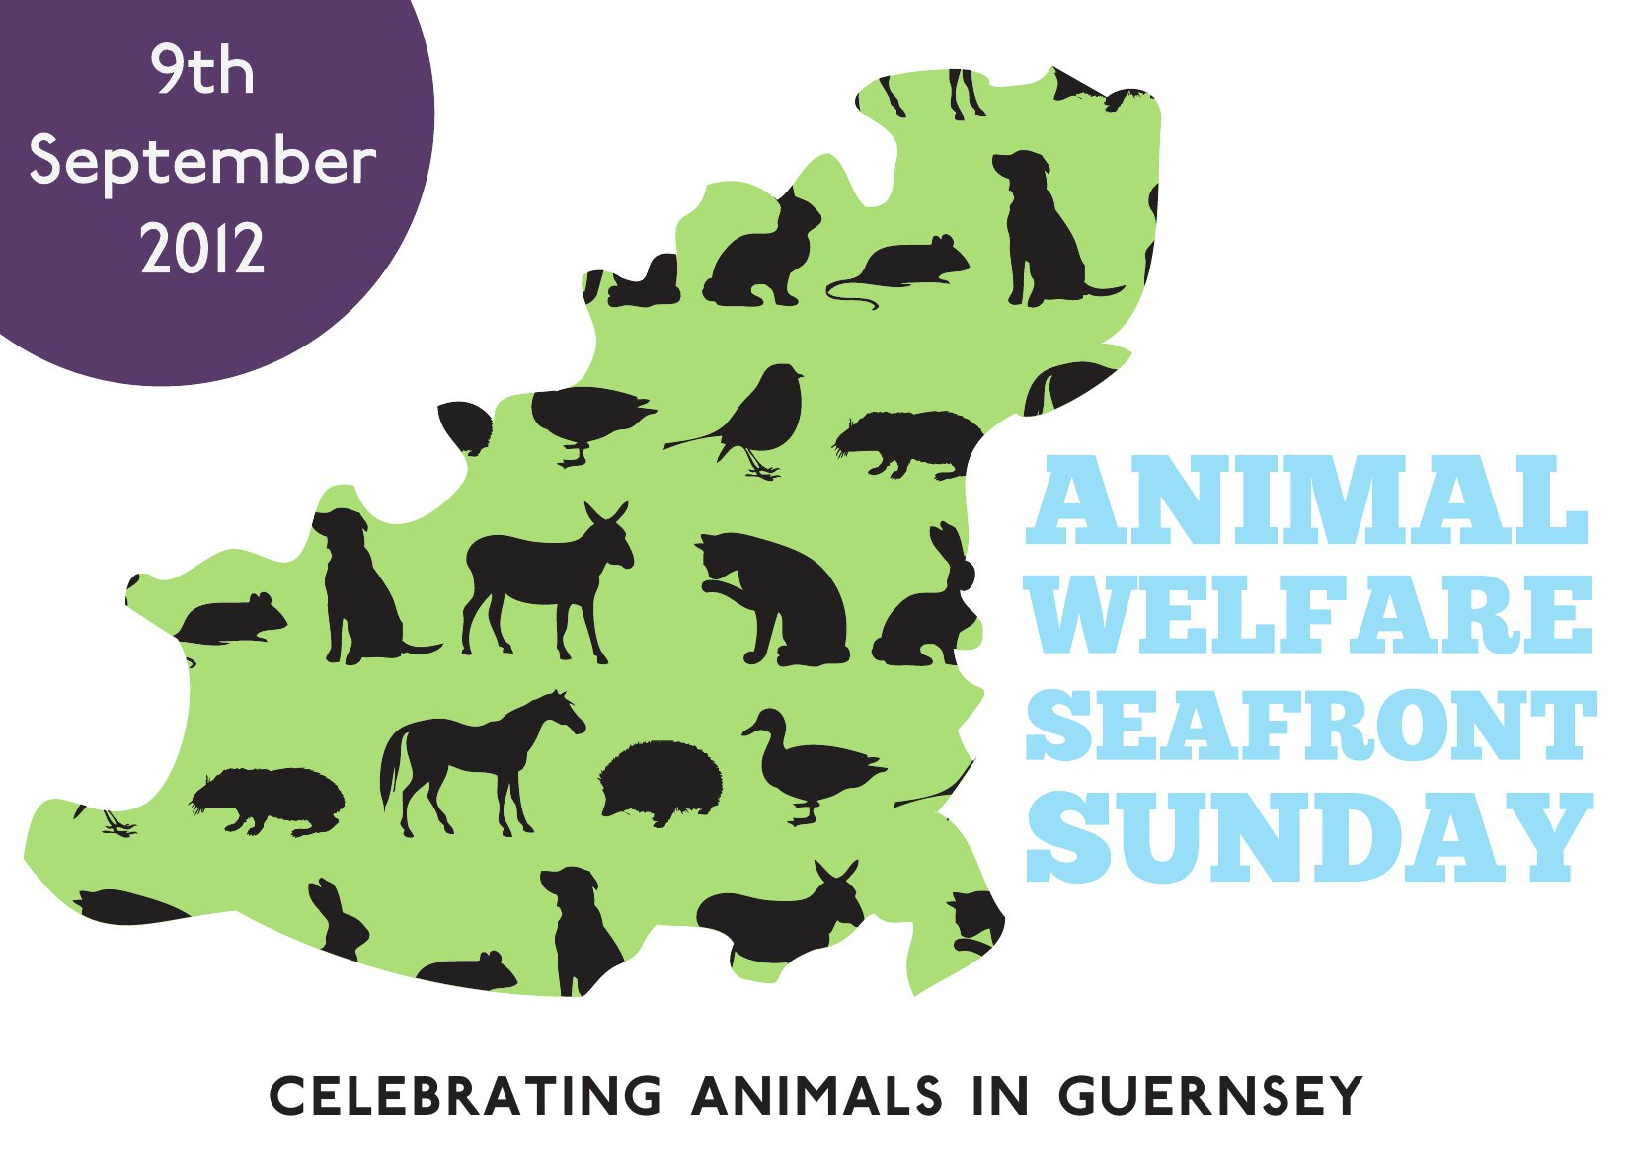

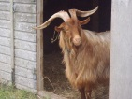
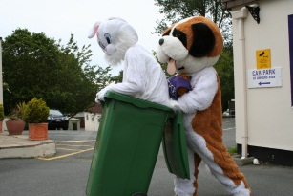
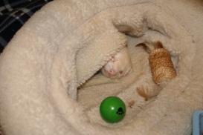
A day to celebrate animals in Guernsey along the Sea Front in St Peter Port Sunday 9th September 10am-4pm

Stalls, food, games & fun for all the family
Animal Charities from around Guernsey
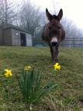
Mascot Racing & Doggy Dancing Workshop
Animal Fancy Dress Wheelie Bin Racing
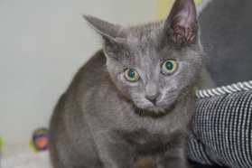
Kids Animal Fancy Dress Competition & Pupcake Making
Fun Dog Show & Animal Less Photo Show
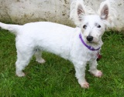
Arts & Crafts Stalls many with animal themes
Face & Nail Painting, Children’s Activities & Rides
For more details please go to - www.gspca.org.gg
To sponsor or take part please contact 01481 257261 or email stevejbyrne@gspca.org.gg

