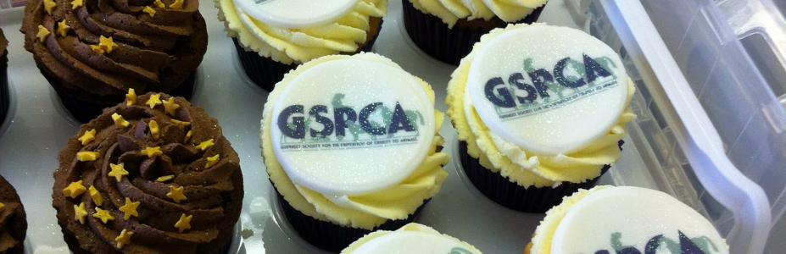
EASTER FAYRE AND CUPCAKE AND PUPCAKE COMPETITION
SATURDAY 31ST MARCH 11AM – 3.30PM
MEET BERNARD OUR MASCOT, SEE OUR GIANT EASTER BUNNY, PAT OUR DONKEYS, SEE A DISPLAY OF OUR RABBITS LOOKING FOR HOMES, KIDS HAVE AN EASTER EGG ASSUALT COURSE, COLOUR A BUNNY MASK, HOOK A DUCK, TOMBOLA, RAFFLE, BACON ROLLS, LOTS OF CAKES AND CHOCOLATE, TEA AND COFFEE, LOTS TO DO AND SEE
