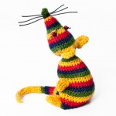
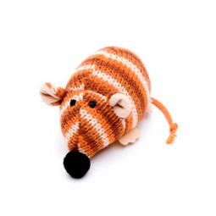
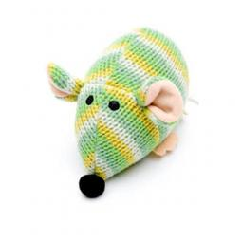
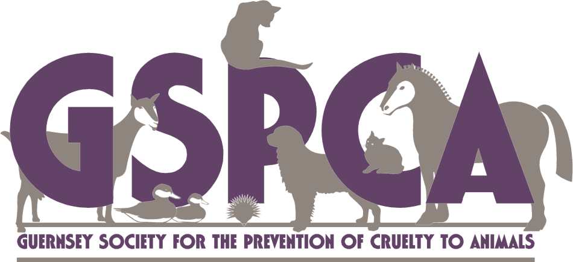

Knit a mouse for a homeless cat
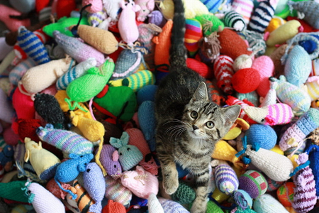
We are always looking for new and exciting ways to provide stimulation and environmental enrichment for our feline friends. Whether you are an experienced knitter or perhaps someone who just wants to give it a go and would like to help please accept this invitation to get knitting and create a fun an interactive toy for the cats at the GSPCA. You can either drop your finished mouse into the Shelter or post them to the address below.

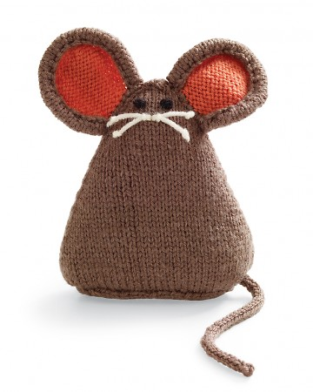
The GSPCA,
Les Fiers Moutons, St Andrews, Guernsey GY6 8UD
Tel: 01481 257261
Thank you

