SEAFRONT SUNDAY PITCH APPLICATION

General Information

Name:
Address:
Post Code:
Telephone: |  | Fax |  | Other
Charity / Company:
Address:
Post Code:
Telephone: |  | Fax |  | Other
Email:

Pitch Information

Size of area required :
Type of pitch (e.g tables, gazebo, van, etc.):
Charity: | Yes / No | Business | Yes / No | Other  Please specify

Charity Stalls are free of charge

Business stalls there is a charge of £15 to be sent by the 15th August 2013

We are afraid that we cannot guarantee power and we have limited cover although we are appealing for gazebos and marquees (please ask for more details)

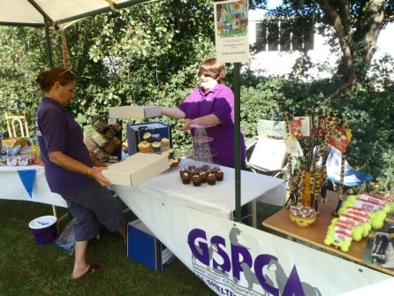Please return all forms and payment to
Steve Byrne
GSPCA Manager
GSPCA Animal Shelter
Les Fiers Moutons
Guernsey
GY6 8UD

Email - stevejbyrne@gspca.org.gg
Tel - 01481 257261

